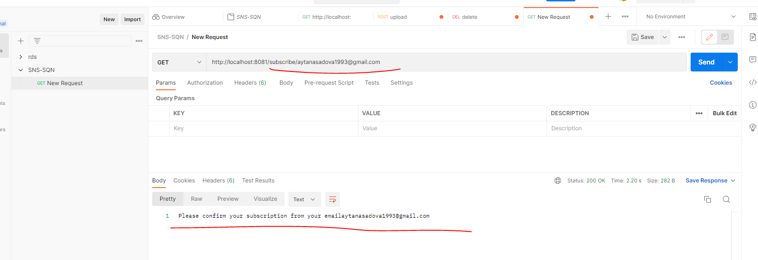

Whenever an image is uploaded using your web application, a message describing that event should be published to the SQS queue.

